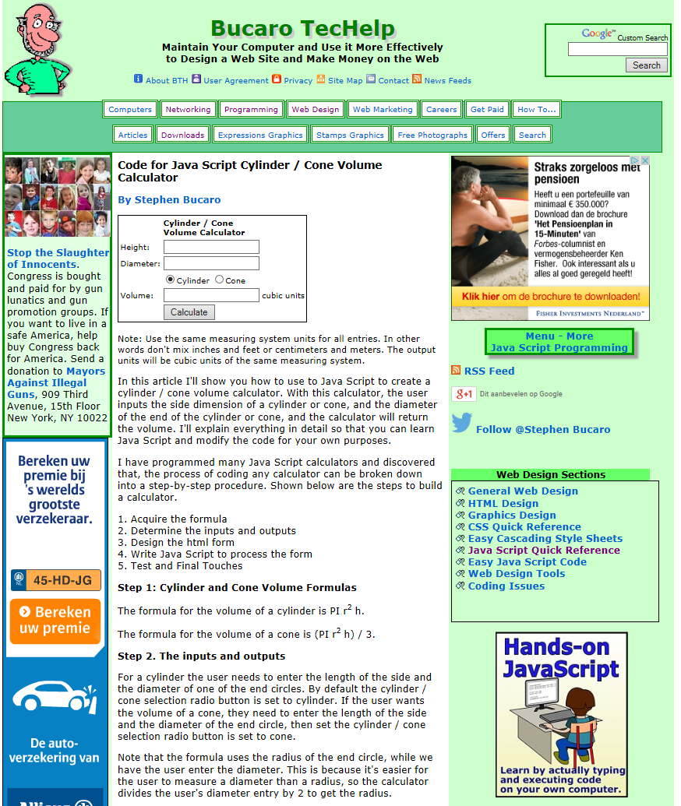
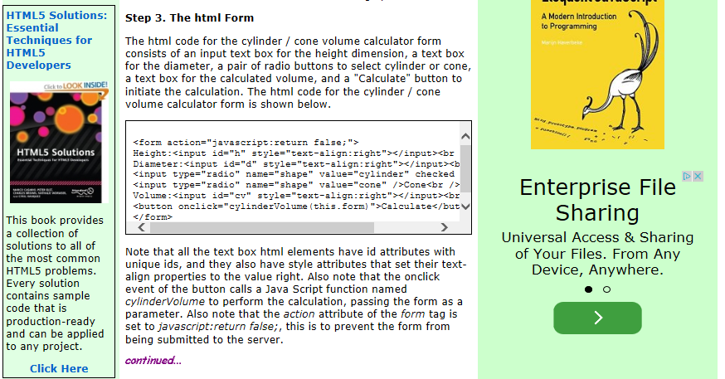

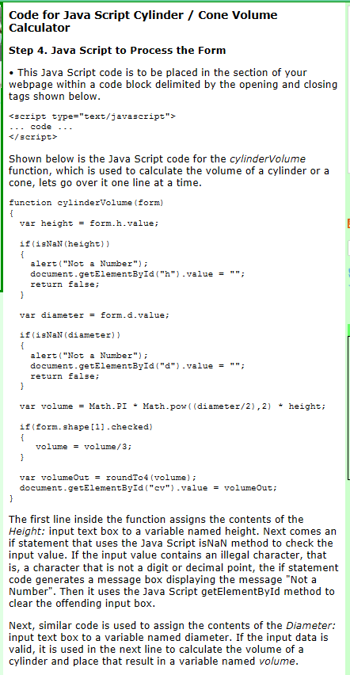
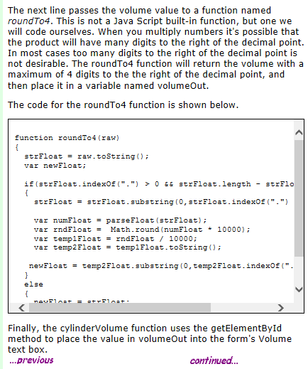

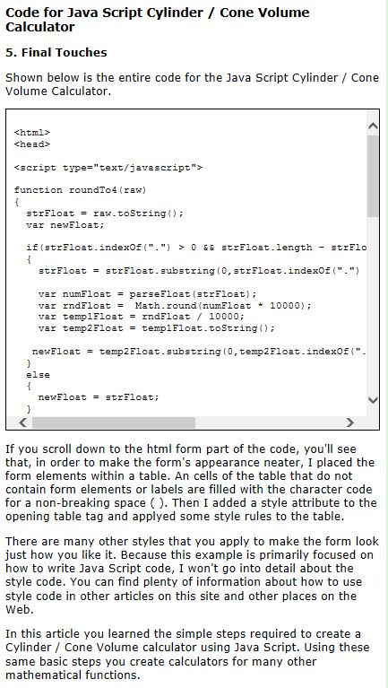
<html>
<head>

<meta charset="utf-8"/>

<title>Volume Cal. Cilinder-Cone</title>

<script type="text/javascript">

function roundTo4(raw)
{
strFloat = raw.toString();
var newFloat;

if(strFloat.indexOf(".") > 0 && strFloat.length - strFloat.indexOf(".") > 5)
{
strFloat = strFloat.substring(0,strFloat.indexOf(".") + 6);

var numFloat = parseFloat(strFloat);
var rndFloat = Math.round(numFloat * 10000);
var temp1Float = rndFloat / 10000;
var temp2Float = temp1Float.toString();

newFloat = temp2Float.substring(0,temp2Float.indexOf(".") + 5);
}
else
{
newFloat = strFloat;
}
return newFloat;
}

function cylinderVolume(form)
{
var height = form.h.value;

if(isNaN(height))
{
alert("Not a Number");
document.getElementById("h").value = "";
return false;
}

var diameter = form.d.value;

if(isNaN(diameter))
{
alert("Not a Number");
document.getElementById("d").value = "";
return false;
}

var volume_mm3 = Math.PI * Math.pow((diameter/2),2) * height;

if(form.shape[1].checked)
{
volume_mm3 = volume_mm3/3;
}

var volumeOut = roundTo4(volume_mm3);
document.getElementById("cv_mm3").value = volumeOut;

//nu in dm3

var volume_dm3 = Math.PI * Math.pow((diameter/2),2) * height/1000;

if(form.shape[1].checked)
{
volume_dm3 = volume_dm3/3;
}

var volumeOut = roundTo4(volume_dm3);
document.getElementById("cv_dm3").value = volumeOut;

//nu in m3

var volume_m3 = Math.PI * Math.pow((diameter/2),2) * height/1000000;

if(form.shape[1].checked)
{
volume_m3 = volume_m3/3;
}

var volumeOut = roundTo4(volume_m3);
document.getElementById("cv_m3").value = volumeOut;

}

</script>

</head>
<body>

<center>

<img src="Gegevens_Info\Bodems\Kegel.jpg" alt="Bemating kegel">

<form action="javascript:return false;">
<table style="font-family:verdana; font-size:18px; border-style:solid; border-color:blue; border-width:8px;">
<tr><td> </td> <td><b>Cylinder / Cone<br />Volume Calculator</b></td><td> </td></tr>

<tr><td> </td><td>

<input type="radio" name="shape" value="cylinder" checked />Cylinder
<input type="radio" name="shape" value="cone" />Cone

</td><td> </td></tr>

<tr></tr>

<tr><td>Height:</td><td><input id="h" style="text-align:right"></input><td>mm</td></td><td> </td></tr>
<tr><td>Diameter:</td><td><input id="d" style="text-align:right"></input><td>mm</td></td><td> </td></tr>

<tr><td> </td><td><button onclick="cylinderVolume(form)">Calculate</button></td><td> </td></tr>

<tr><td>Volume:</td><td><input id="cv_mm3" style="text-align:right"></input></td><td>mm3</td></tr>
<tr><td>Volume:</td><td><input id="cv_dm3" style="text-align:right"></input></td><td>dm3 = ltr</td></tr>
<tr><td>Volume:</td><td><input id="cv_m3" style="text-align:right"></input></td><td>m3</td></tr>

</table>
</form>

</body>
</html>

